**Azure cloud**

**POC**

Table of Contents

Problem statement: 3

Design Solution: 3

Design Benefit: 3

Code Link: 4

More benefit refer the pointer as below: 4

# Problem statement:

* A REST API service (a .Net code) that can
  + Invoke a REST end-point (Get)
  + Send parameters and extract the output
  + Form the output in CSV format and save it
* This code should  run in your Azure cloud POC that you are developing

# Design Solution:

Simple design where I will be using Azure function for creating solution. Transformation pipeline as shown below:

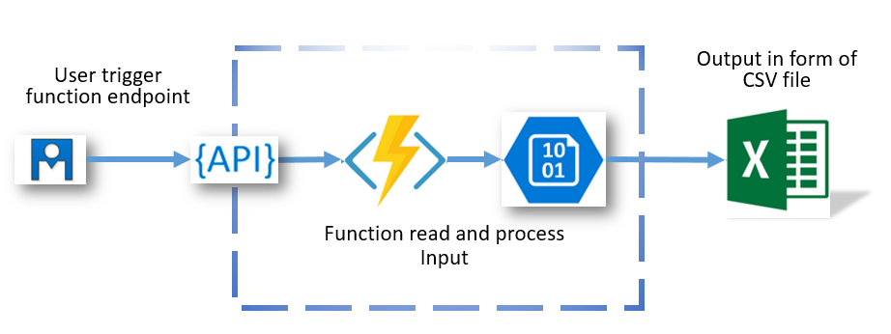

# Design Benefit:

* [Serverless app model](https://azure.microsoft.com/solutions/serverless/) with [automatic scaling](https://docs.microsoft.com/en-us/azure/azure-functions/functions-scale#how-the-consumption-and-premium-plans-work)
* [Develop and test in browser](https://docs.microsoft.com/en-us/azure/azure-functions/functions-create-first-azure-function)
* [Integration with Logic Apps](https://docs.microsoft.com/en-us/azure/azure-functions/functions-twitter-email)
* Can run [locally](https://docs.microsoft.com/en-us/azure/azure-functions/functions-runtime-overview) or in the cloud
* Supported languages: C#, F#, JavaScript, Java, Python, PowerShell
* Trigger events:
  + [Azure Storage queues and blobs](https://docs.microsoft.com/en-us/azure/azure-functions/functions-bindings-storage-blob)
  + [Azure Service Bus queues and topics](https://docs.microsoft.com/en-us/azure/azure-functions/functions-bindings-service-bus)
  + [Azure Cosmos DB](https://docs.microsoft.com/en-us/azure/azure-functions/functions-bindings-cosmosdb)
  + [Azure Event Hubs](https://docs.microsoft.com/en-us/azure/azure-functions/functions-bindings-event-hubs)
  + [HTTP/WebHook (GitHub, Slack)](https://docs.microsoft.com/en-us/azure/azure-functions/functions-bindings-http-webhook)
  + [Azure Event Grid](https://docs.microsoft.com/en-us/azure/azure-functions/functions-bindings-event-grid)
* Can run locally or in the cloud

# Code Link:

<https://github.com/gauravlion/CloudETLPOC>

# More benefit refer the pointer as below:

<https://docs.microsoft.com/en-us/azure/azure-functions/functions-compare-logic-apps-ms-flow-webjobs>